Database Synchronized Web Form Builder  
Software Requirement Specification

Project for Stephan Lam, [Germanfai@freelancer.com](mailto:Germanfai@freelancer.com)

Documented by Johnny Rine, Freelancer

Feb 15, 2017

[johnnyri420@freelancer.com](mailto:johnnyri420@freelancer.com)

# Project Objective

There are lots of web design tool to build a responsive websites with Bootstrap framework, such as Pinegrow and Bootstrap Studio. However, the tools are just offering a user interface to drag out the HTML controls and build a web page without cooperating with any database table.

As such, the goal of this project is to build a web design tool which is working with a database. The web design tool should use NW.JS to develop.

# Key Features

* Live HTML edit

It allows users to create a responsive HTML page by drag & drop the controls into the page so that they can build their web page in WYSIWYG mode.

* Database-synchronized HTML controls

It allows users to use the customized HTML controls which were derived from database tables and fields so that they can build their database web applications GUI efficiently.

* Database-synchronized form and tables

It allows users to connect their forms and tables to the specified database tables directly so that they can build their database web application efficiently without writing the code in server-side programming language such as PHP or Node.js.

* Publishing the pages to a folder

It allows users to publish the created pages into a folder with necessary resources.

# Additional features

* Validation

All forms created should provide validation such as check null, required, email and phone number format checking. It might be supported by setting “Validation” property of the specified control.

* Change language

The label of the control should have multiple language support. It might be supported by setting “Language” property of the specified control.

* Copy form

The form created by builder can be duplicated. It might be supported by duplicating the page.

* Editable/visible HTML controls

It might be supported by setting “Editable” or “Visible” property of the specified control.

* Every form has a "next button" to call API to perform next action

It might be supported by setting the page order in the property of the case.

* Lock page if it is editing by other users

This is the case of multiple users access to one page to edit it. It might be handled by file open permission handling.

# Postponed features

* Tree-view of HTML elements

Pinegrow shows element stack as below;

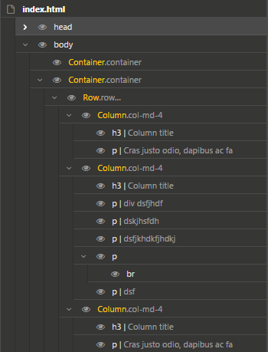

This is not essential feature for this product but needs very much efforts so that it is postponed and not quoted.

*Johnny’s team will go through full investigation and document all the features of Pinegrow and suggest which features must and can be provided in the initial version under the quotation of below, then the customer approve/reject the features or advance more features.*

# Quotation

* Estimated efforts
  + Developers needed;
    - 1 NW.js developer: in charge of application framework, main logic module and GUI development
    - 1 web developer: in charge of HTML control manipulation module development
    - 1 tester & assistant: in charge of progressive test including internal UAT and assist manager in deliveries and customer support
    - 1 manager & SW architect: in charge of requirement engineering and documenting, design and process management
  + Estimated efforts (man hours)
    - Requirement engineering/design: 200
    - Development 8 000
    - Test 500
    - Deliveries/customer support 300
    - **Total 9 000\***
* Expected delivery date
  + Intermediate results including source repository will be delivered per month
  + The trial version will be delivered by May 31, 2017
  + Final version will be delivered by June 30, 2017

# Milestones

|  |  |  |
| --- | --- | --- |
| Milestone | Expected deliveries | Expected payment (HKD) |
| Feb 18 | * Quotation(updated) * Wireframe (*conceptual, refined*) | 200 |
| Feb 28 | * Documenting all features of Pinegrow and suggest features can and must be implemented, * Software requirement specification, * Wireframe(*full*) | 500 |
| Mar 31 | * NW.js application with GUI skeleton but showing the database-synchronized controls | 3 000 |
| Apr 30 | * Live HTML editing with database-synchronized controls and CSS manipulation | 6 000 |
| May 31 | * Dynamic actions such as links and Javascript functions form/table synchronization with database tables | 15 000 |
| June 30 | * All test-passed deliverable including source repository and release note & sign off | 5 000 |

*Each milestones should be awarded to Johnny team as a new job and closed with the expected deliveries including full working source code for the customer to review the progress and also be paid as the deliveries were accepted.*

*We will appreciate if all fees of the transactions are in charge of the customer.*